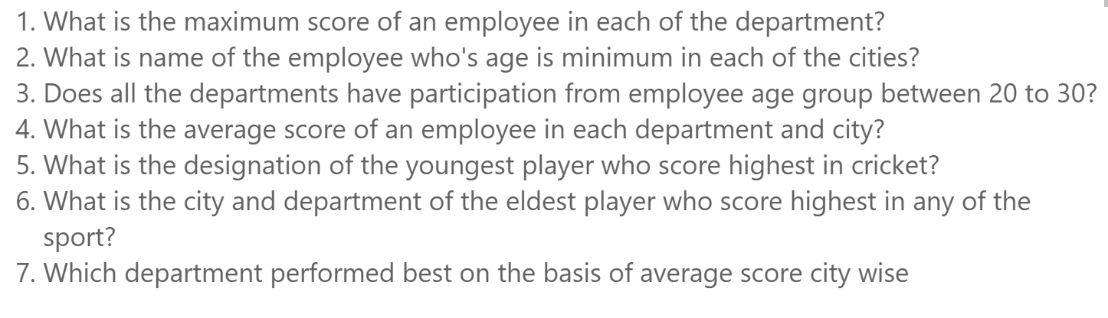

For master_data_excel

Q1. What is the maximum sport score of an employee in each of the department?

**Q2. What is the name of employee who's age is minimum in each of the cities?**

**Q3. What is the mininum and maximum age of an employee in each department within the city?**

**Q4. What is the avarage sports score of an employee in each department within the city?**

**Q5  Designation of the Youngest Player Who Scored Highest in Cricket**

**Q6 City and Department of the Eldest Player Who Scored Highest in Any Sport**

Q7 **Department that Performed Best on the Basis of Average Score City-wise**